**Create and Deploy Azure Resource Manager templates by Azure Portal**

In this demo we will create one storage account and download template using automation script.

We will edit json file and then try to deploy that resource from the template.

**Step 1:** Open Azure Portal and enter credentials

<https://portal.azure.com/>

**Step 2:** Click on **+ Create a resource -> Storage -> Storage account – blob, file, table, queue**

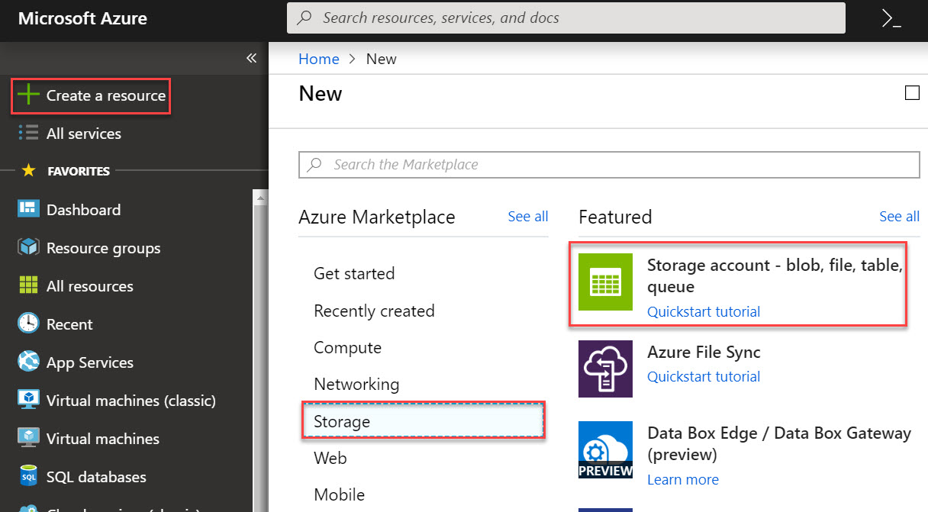

**Step 3:** Click on **Create New** resource. Ex. storagedemoRG

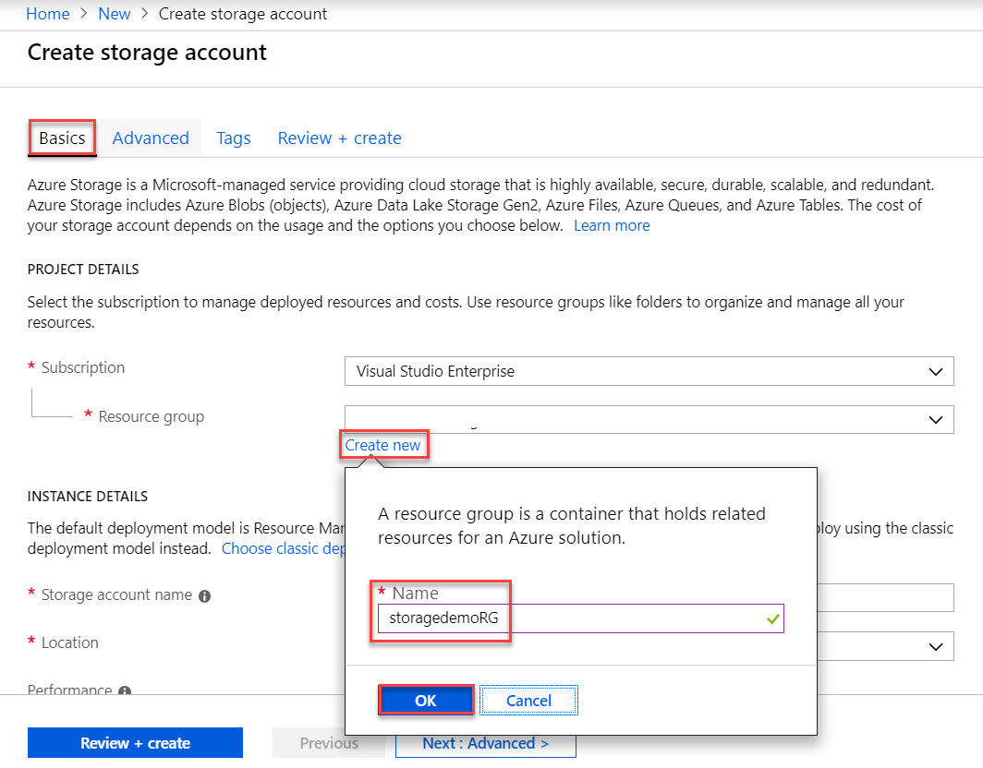

Enter storage account name, Location, Replication

Click on **Review + create** button

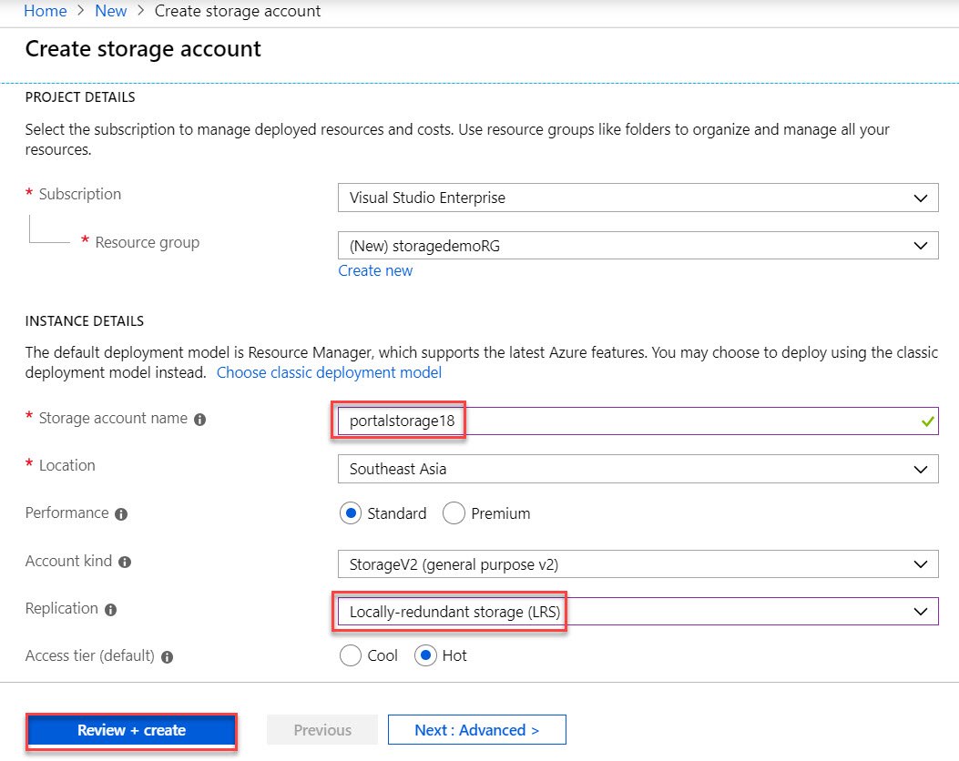

Validation Passed and Click on **Create** button.

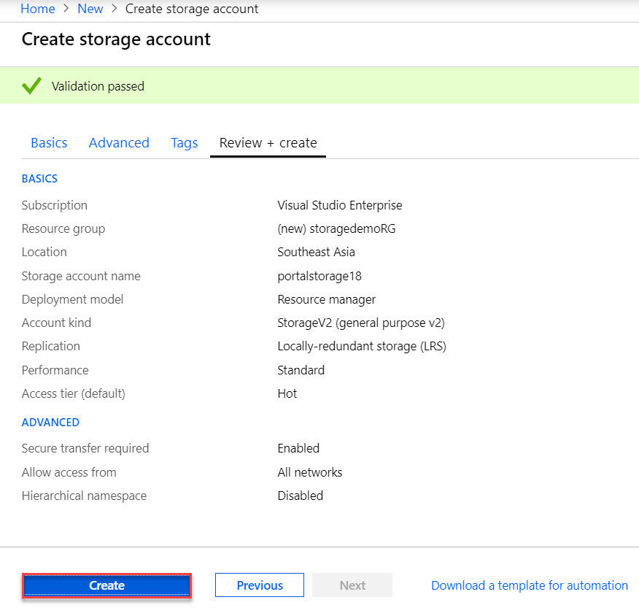

**Step 4:** Automation **script -> Template** -> Click on **Download**

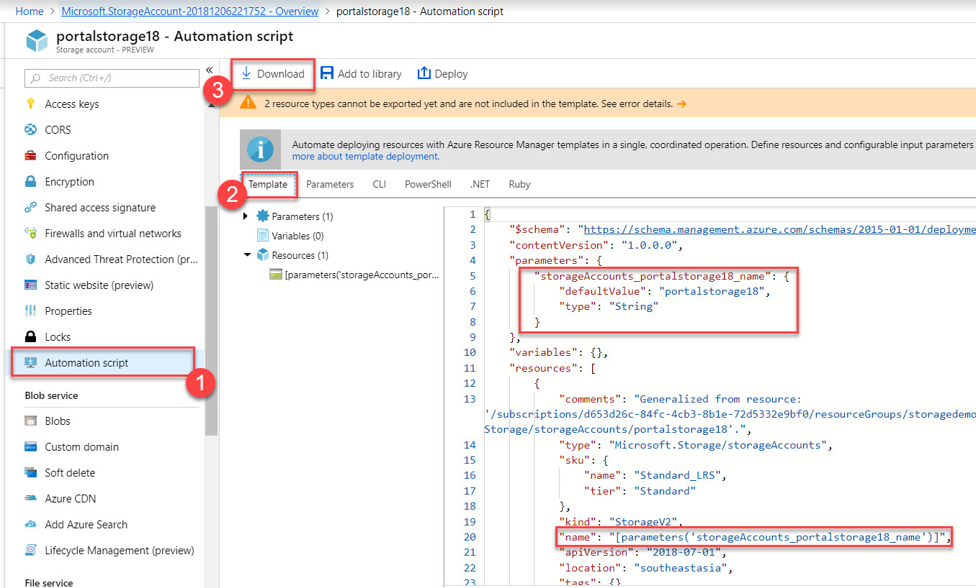

**Step 5:** Click on **+ Create a resource** -> search for **template**

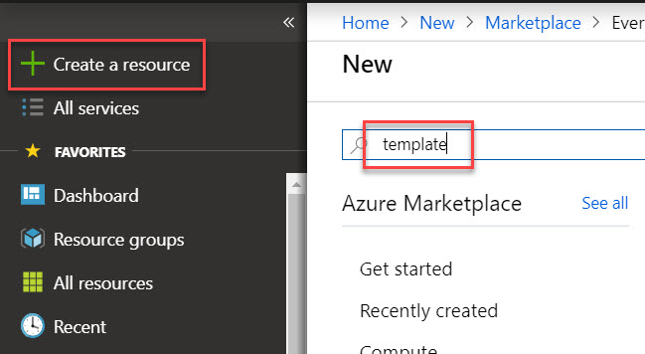

Click on **Template deployment**

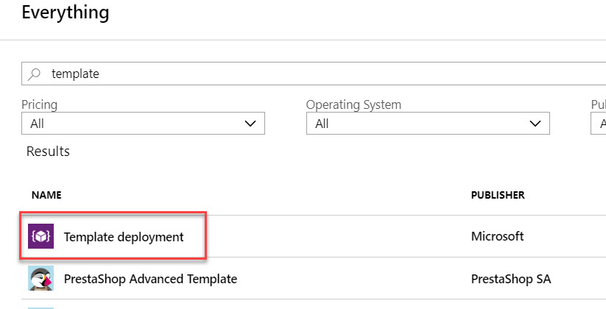

**Step 6:** Click on **Build your own template in the editor**

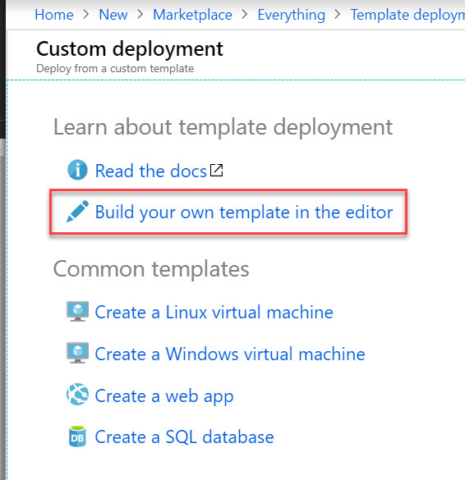

**Step 7:** Edit template blade will open.

Click on **Load file** option.

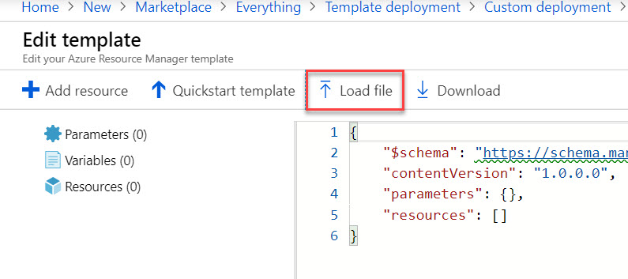

Browse **template.json** file which we have downloaded in previous steps.

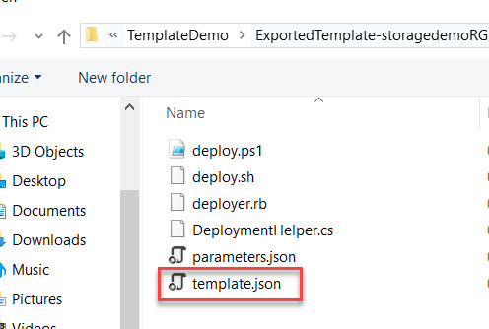

**Step 8:** Now **template.json** file loaded

Remove storage account parameter

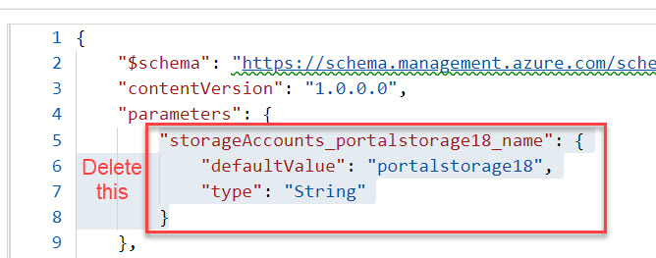

* Add storage account name variable – concat() and uniquestring() function

"storageAccountName": "[concat(uniquestring(resourceGroup().id), 'demo')]"

* Update the name resources

"name": "[variables('storageAccountName')]",

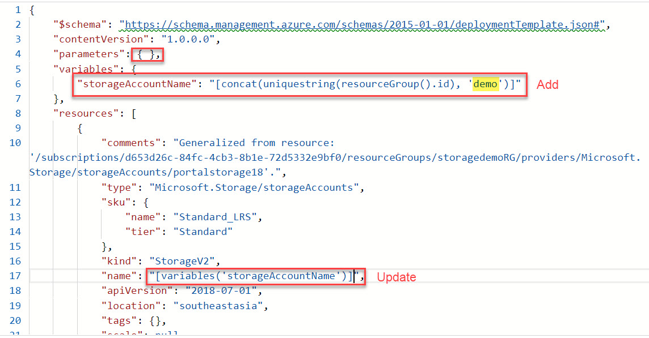

Click on **save** button

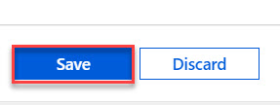

**Step 9:** After clicking on Save button, custom deployment blade will open

**Resource Group:** select same resource group

**Tick – I Agree to the terms and conditions stated above**

Click on **Purchase** button

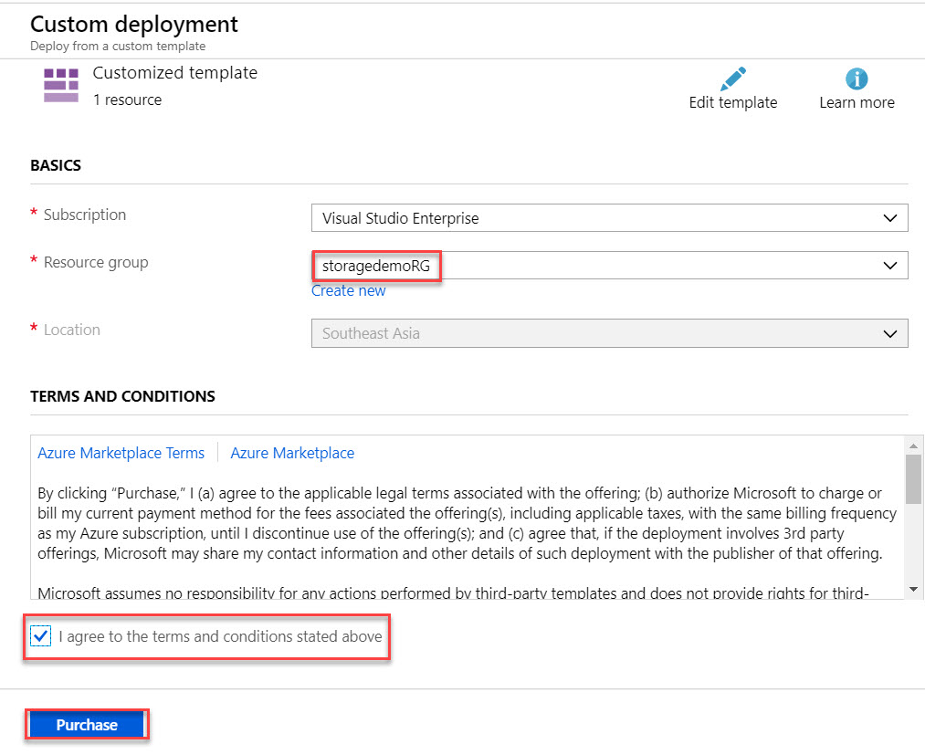

You can see new storage account name with concat() function.

